**Router 1x3 Project Report**



By,

T Raja Aadhithan

BRN10

**INDEX**

|  |  |  |  |  |  |
| --- | --- | --- | --- | --- | --- |
| **MODULE** | FIFO | FSM | SYNC | REGISTER | TOP |
| **PAGE NO** | 2 | 8 | 14 | 19 | 25 |

**FIFO :**

RTL:

module router_fifo(input clock, resetn, write_enb, read_enb, soft_reset, lfd_state,

                   input [7:0] data_in, output full, empty, output [7:0] data_out);

reg [8:0] mem [0:15];

reg [3:0] rd_pointer, wr_pointer;

reg [8:0] packet_out;

wire [8:0]packet;

reg [5:0] length;

reg [4:0] status_count = 0;

assign empty = (status_count == 0 ) ? 1'b1 : 1'b0 ;

assign full = (status_count == 5'd16) ? 1'b1 : 1'b0 ;

assign packet[7:0] = data_in[7:0];

assign packet[8] = lfd_state;

assign data_out = resetn ?  packet_out[7:0] : 8'd0;

always@(posedge clock) begin

    if(full == 1'b0 && write_enb & empty == 1'b0 && read_enb) status_count <= status_count;

    else if (full == 1'b0 && write_enb) status_count <= status_count + 1'b1;

    else if(empty == 1'b0 && read_enb ) status_count <= status_count - 1'b1;

    else status_count <= status_count;

end

//write block:

always@(posedge clock) begin

    if(!resetn || soft_reset) begin //reset

        wr_pointer <= 4'd0;

    end

    else if(full == 1'b0 && write_enb) begin //only write

            mem[wr_pointer[3:0]] <= packet;

            wr_pointer <= wr_pointer + 1'b1;

    end

end

//read block:

always@(posedge clock) begin

    if(!resetn || soft_reset) begin //reset

        rd_pointer <= 4'd0;

        packet_out <= 8'dz;

    end

    else begin

        if(empty == 1'b0 && read_enb ) begin //only write

                packet_out <= mem[rd_pointer[3:0]];

                rd_pointer <= rd_pointer + 1'b1;

        end

        if (length == 0 && !mem[rd_pointer[3:0]][8]) packet_out <= 8'bz;

    end

end

always@(posedge clock)begin

    if (!resetn || soft_reset) begin

        length <= 0;

    end

    else if(empty == 1'b0 && read_enb ) begin

        if(mem[rd_pointer[3:0]][8])begin

                length <= mem[rd_pointer[3:0]][7:2] + 1'b1;

        end

        else if (length != 0)  begin

                length <= length - 1'b1;

        end

    end

end

endmodule

TB :

module router_fifo_tb();

reg clock, resetn, write_enb, read_enb, soft_reset, lfd_state;

reg [7:0] data_in;

wire full, empty;

wire [7:0] data_out;

router_fifo DUT(clock, resetn, write_enb, read_enb, soft_reset, lfd_state, data_in, full, empty, data_out);

initial begin

    clock = 1'b1;

    forever #5 clock = !clock;

end

task write(input [7:0]data);

    begin

        lfd_state = 0;

        write_enb = 1;

        data_in = data;

        #10;

        write_enb = 0;

    end

endtask

task header(input [5:0]data,input [1:0]set);

    begin

        write_enb = 1;

        lfd_state = 1;

        data_in = {data,set};

        #10;

        write_enb = 0;

    end

endtask

task read();

    begin

        read_enb = 1;

        #10;

        read_enb = 0;

    end

endtask

task readandwrite(input [7:0]data);

begin

        lfd_state = 0;

        write_enb = 1;

        data_in = data;

        read_enb = 1;

        #10;

        read_enb = 0;

        write_enb = 0;

    end

endtask

initial begin

    $monitor("@time: %t, data_in: %h, data_out: %h, lfd: %b, full: %b, empty: %b",$time, data_in, data_out, lfd_state, full, empty);

    resetn = 1'b0;

    repeat(3)

    @(negedge clock);

    resetn = 1'b1;

    header(6'd14,{$random}%3);// 6'dx denotes the paylength, %3 selects the fifo from 0 to 2

    repeat(15) // payload length is denoted here

    write({$random}%256);

    repeat(15)

    read();

    repeat(3)

    readandwrite({$random}%256);

    repeat(15)

    read();

    soft_reset = 1'b1;

    #20;

    soft_reset = 1'b0;

    #20;

    header(6'd4,{$random}%3);

    repeat(4) // payload length is denoted here

    write({$random}%256);

    repeat(15)

    read();

    $finish;

end

endmodule

Waveform :

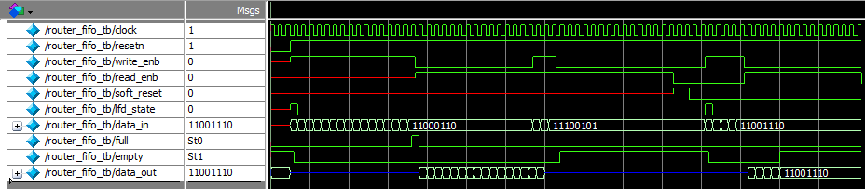

RTL Netlist:

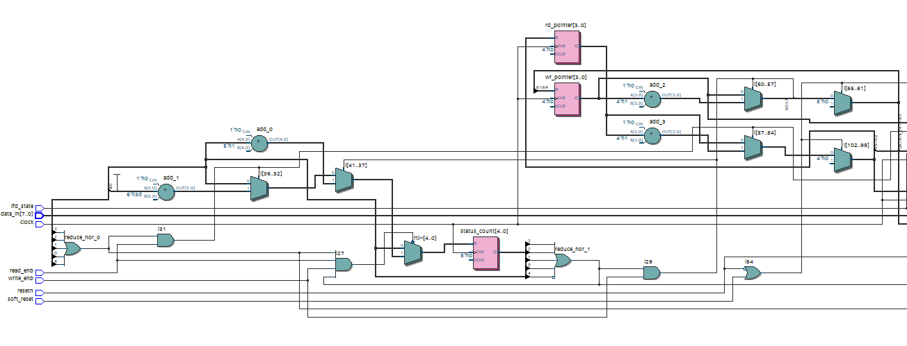

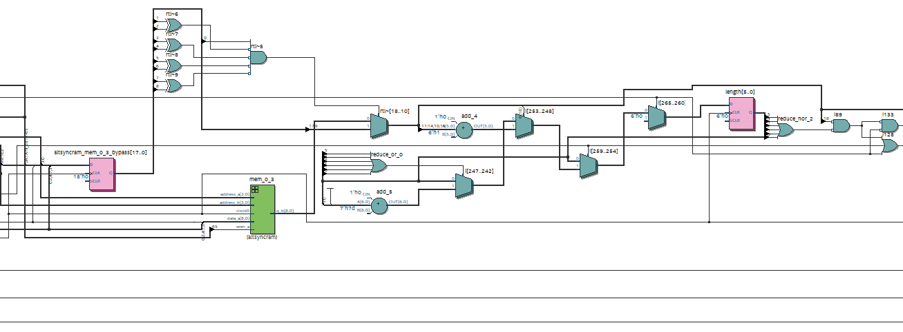

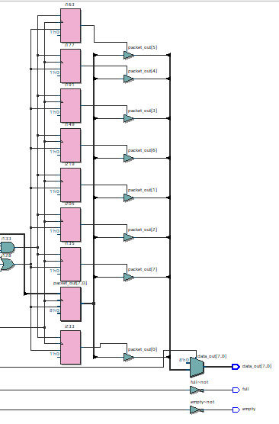

**FSM :**

RTL:

module router_fsm(input clock, resetn, pkt_valid, parity_done,

                        soft_reset_0, soft_reset_1, soft_reset_2,

                        fifo_full, low_pkt_valid,

                        fifo_empty_0, fifo_empty_1, fifo_empty_2,

                        input [1:0] data_in,

                        output busy, detect_add, ld_state, laf_state,

                        full_state, write_enb_reg, rst_int_reg, lfd_state);

parameter Decode_Address = 3'b000,

          Load_First_Data = 3'b001,

          Wait_Till_Empty = 3'b010,

          Load_Data = 3'b011,

          Check_Parity_Error = 3'b100,

          Load_Parity = 3'b101,

          Fifo_Full_State = 3'b110,

          Load_After_Full = 3'b111;

reg [2:0] state, next_state;

always @(posedge clock) begin

    if (!resetn) state <= Decode_Address;

    else if((soft_reset_0 && (data_in[1:0] == 0)) | (soft_reset_1 && (data_in[1:0] == 1)) | (soft_reset_2 && (data_in[1:0] == 2))) state <= Decode_Address;

    else state <= next_state;

end

always @(*) begin

    case(state)

    Decode_Address : begin //1st case

        if(pkt_valid & (data_in[1:0] == 0 & fifo_empty_0 | data_in[1:0] == 1 & fifo_empty_1 | data_in[1:0] == 2 & fifo_empty_2))

        begin

            next_state = Load_First_Data;

        end

        else if(pkt_valid & (data_in[1:0] == 0 & !fifo_empty_0 | data_in[1:0] == 1 & !fifo_empty_1 | data_in[1:0] == 2 & !fifo_empty_2))

        begin

            next_state = Wait_Till_Empty;

        end

        else next_state = Decode_Address;

    end

    Load_First_Data : next_state = Load_Data; //2nd case

    Wait_Till_Empty : begin //3rd case

        if( (fifo_empty_0 && (data_in[1:0] == 0)) || (fifo_empty_1 && (data_in[1:0] == 1)) || (fifo_empty_2 && (data_in[1:0] == 2)) ) begin

            next_state = Load_First_Data;

        end

        else next_state = Wait_Till_Empty;

    end

    Load_Data : begin //4th case

        if(fifo_full) next_state = Fifo_Full_State;

        else if (!fifo_full & !pkt_valid) next_state = Load_Parity;

        else next_state = Load_Data;

    end

    Fifo_Full_State : begin //5th case

        if(!fifo_full) next_state = Load_After_Full;

        else next_state = Fifo_Full_State;

    end

    Load_Parity : next_state = Check_Parity_Error; //6th case

    Check_Parity_Error : begin //7th case

        if(fifo_full) next_state= Fifo_Full_State;

        else next_state = Decode_Address;

    end

    Load_After_Full : begin //8th case

        if (parity_done) next_state = Decode_Address;

        else if(low_pkt_valid) next_state = Load_Parity;

        else next_state = Load_Data;

    end

    endcase

end

assign detect_add = (state == Decode_Address);

assign lfd_state = (state == Load_First_Data);

assign busy = (state == Load_First_Data) || (state == Load_Parity) || (state == Fifo_Full_State) || (state == Load_After_Full) || (state == Wait_Till_Empty) || (state == Check_Parity_Error);

assign ld_state = (state == Load_Data)||(state == Load_Parity) ;

assign write_enb_reg = (state == Load_First_Data)|(state == Load_Data)||(state == Load_Parity);

assign full_state = (state == Fifo_Full_State);

assign laf_state = (state == Load_After_Full);

assign rst_int_reg = (state == Check_Parity_Error);

endmodule

TB :

module router_fsm_tb();

reg clock, resetn, pkt_valid, parity_done, soft_reset_0, soft_reset_1, soft_reset_2,

    fifo_full, low_pkt_valid, fifo_empty_0, fifo_empty_1, fifo_empty_2;

reg [1:0] data_in;

wire busy, detect_add, ld_state, laf_state, full_state, write_enb_reg, rst_int_reg, lfd_state;

router_fsm dut(clock, resetn, pkt_valid, parity_done, soft_reset_0, soft_reset_1, soft_reset_2,

    fifo_full, low_pkt_valid, fifo_empty_0, fifo_empty_1, fifo_empty_2,data_in,

    busy, detect_add, ld_state, laf_state, full_state, write_enb_reg, rst_int_reg, lfd_state);

initial begin

    clock = 1'b1;

    forever #5 clock = !clock;

end

task ts1();

    begin

        resetn = 0;

        @(negedge clock);

        resetn = 1;

        @(negedge clock);

        pkt_valid = 1'b1;

        data_in = 2'b0;

        fifo_empty_0 = 1'b1;

        @(negedge clock);

        fifo_full = 1'b0;

        pkt_valid = 1'b0;

    end

endtask

task ts2();

begin

    pkt_valid = 1'b1;

    data_in = 2'b10;

    fifo_empty_2 = 1'b1;

    repeat(3)

    @(negedge clock);

    fifo_full = 1'b1;

    @(negedge clock);

    fifo_full = 1'b0;

    @(negedge clock);

    parity_done = 1'b0;

    low_pkt_valid = 1'b1;

    @(negedge clock);

    fifo_full = 1'b0;

    pkt_valid = 1'b0;

end

endtask

task ts3();

begin

    pkt_valid = 1'b1;

    data_in = 2'b10;

    fifo_empty_2 = 1'b1;

    repeat(3)

    @(negedge clock);

    fifo_full = 1'b1;

    @(negedge clock);

    fifo_full = 1'b0;

    @(negedge clock);

    parity_done = 1'b0;

    low_pkt_valid = 1'b0;

    @(negedge clock);

    fifo_full = 1'b0;

    pkt_valid = 1'b0;

end

endtask

task ts4();

begin

    pkt_valid = 1'b1;

    data_in = 2'b0;

    fifo_empty_0 = 1'b0;

    #10;

    fifo_empty_0 = 1'b1;

    @(negedge clock);

    fifo_full = 1'b0;

    pkt_valid = 1'b0;

    @(negedge clock);

    fifo_full = 1'b1;

    @(negedge clock);

    fifo_full = 1'b0;

    parity_done = 1'b1;

end

endtask

initial begin

    ts1();

    #100;

    ts2();

    #100;

    ts3();

    #100;

    ts4();

    #300;

    $finish;

end

endmodule

Waveform :

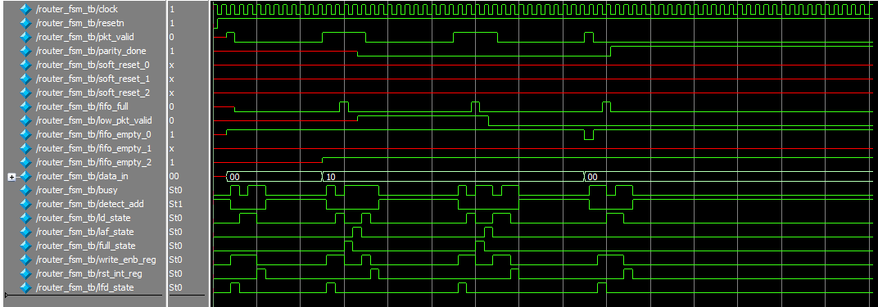

RTL Netlist :

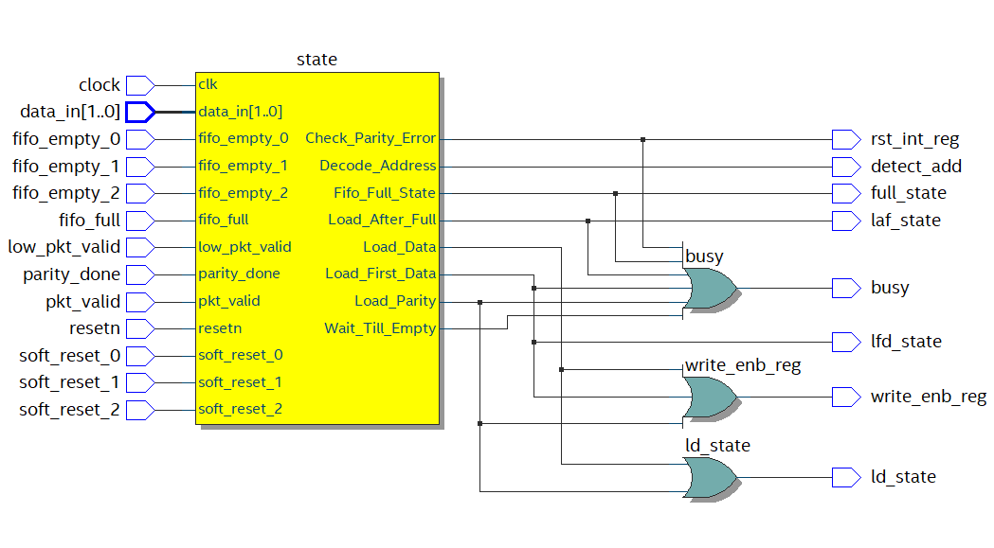

**Synchronizer:**

RTL:

module router_sync(input detect_add, write_enb_reg, clock, resetn,

                         read_enb_0, read_enb_1, read_enb_2,

                         empty_0, empty_1, empty_2,

                         full_0, full_1, full_2,

                   input [1:0] data_in,

                   output reg vld_out_0, vld_out_1, vld_out_2,

                   output reg soft_reset_0, soft_reset_1, soft_reset_2,

                   output reg fifo_full,

                   output reg [2:0] write_enb);

reg [1:0] q;

reg [4:0] count0,count1,count2;

always@(*)begin

    if(detect_add) q<= data_in;

    else q <= q;

    vld_out_0 <= !empty_0;

    vld_out_1 <= !empty_1;

    vld_out_2 <= !empty_2;

    case(q)

    2'b00 : begin

            fifo_full = full_0;

            write_enb = {2'b00, write_enb_reg};

            end

    2'b01 : begin

            fifo_full = full_1;

            write_enb = {1'b0, write_enb_reg,1'b0};

            end

    2'b10 : begin

            fifo_full = full_2;

            write_enb = {write_enb_reg, 2'b00};

            end

    default : begin

                fifo_full = 0;

                write_enb = 3'd0;

    end

    endcase

end

always@(posedge clock) begin

    if(!resetn)begin

        count0<=5'd0;

        count1<=5'd0;

        count2<=5'd0;

    end

    if (vld_out_0) begin

            if (!read_enb_0) begin

              if (count0 == 5'b11101)begin

                    soft_reset_0 <= 1'b1;

                    count0 <= 5'd0;

                end

                else begin

                    soft_reset_0 <= 1'b0;

                    count0 <= count0 + 1'b1;

                end

            end

    end

    if (vld_out_1) begin

            if (!read_enb_1) begin

              if (count1 == 5'b11101)begin

                    soft_reset_1 <= 1'b1;

                    count1 <= 5'd0;

                end

                else begin

                    soft_reset_1 <= 1'b0;

                    count1 <= count1 + 1'b1;

                end

            end

    end

    if (vld_out_2) begin

            if (!read_enb_2) begin

              if (count2 == 5'b11101)begin

                    soft_reset_2 <= 1'b1;

                    count2 <= 5'd0;

                end

                else begin

                    soft_reset_2 <= 1'b0;

                    count2 <= count2 + 1'b1;

                end

            end

    end

end

endmodule

TB:

module router_sync_tb();

  reg detect_add, write_enb_reg, clock, resetn,

      read_enb_0, read_enb_1, read_enb_2,

      empty_0, empty_1, empty_2,

      full_0, full_1, full_2;

  reg [1:0] data_in;

  wire vld_out_0, vld_out_1, vld_out_2,

       soft_reset_0, soft_reset_1, soft_reset_2,

       fifo_full;

  wire [2:0] write_enb;

  router_sync dut(detect_add, write_enb_reg, clock, resetn,

                  read_enb_0, read_enb_1, read_enb_2,

                  empty_0, empty_1, empty_2,

                  full_0, full_1, full_2,data_in,vld_out_0,               vld_out_1, vld_out_2,

                  soft_reset_0, soft_reset_1, soft_reset_2,

                  fifo_full,write_enb);

  initial begin

    clock = 1'b1;

    forever #5 clock = !clock;

  end

  initial begin

    $monitor("@%3dns : q = %b, vldout = %b,%b,%b",$time,soft_reset_0,vld_out_0, vld_out_1, vld_out_2);

    resetn = 1'b0;

    #10;

    resetn = 1'b1;

    empty_0 = 1'b1;

    empty_1 = 1'b0;

    empty_2 = 1'b0;

    data_in = 2'b01;

    detect_add = 1'b1;

    #10;

    detect_add = 1'b0;

    full_1 = 0;

    read_enb_1 = 1'b1;

    read_enb_2 = 1'b0;

    write_enb_reg = 1'b1;

    #10;

    full_1 = 1;

    write_enb_reg = 1'b0;

    #3000;

    read_enb_2 = 1'b1;

    detect_add = 1'b1;

    data_in =2'b10;

    #10;

    detect_add = 1'b0;

    full_2 = 0;

    write_enb_reg = 1'b1;

    #30;

    full_2 = 1;

    write_enb_reg = 1'b0;

    #1000;

    $finish;

  end

endmodule

Waveform:

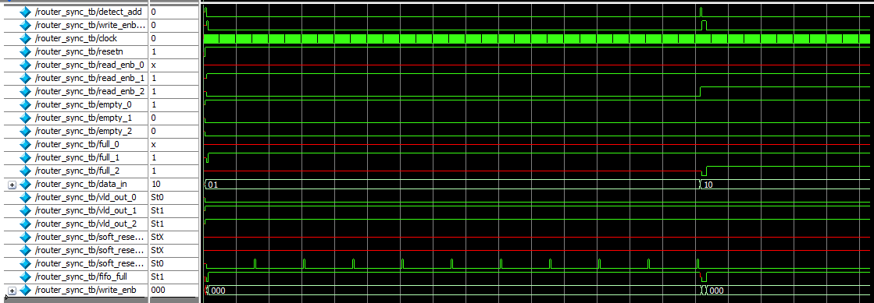

RTL Netlist:

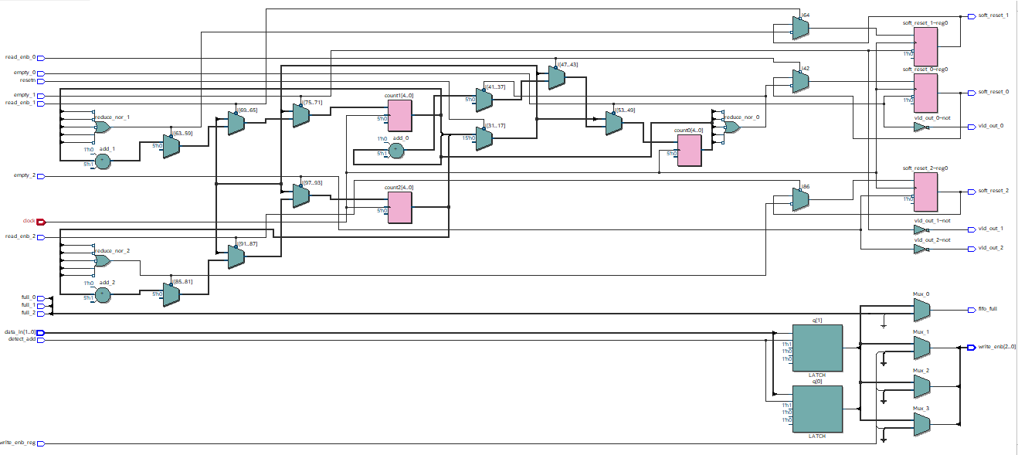

**Register:**

RTL:

module router_reg(input clock, resetn, pkt_valid, fifo_full, rst_int_reg, detect_add,

                        ld_state, laf_state, full_state, lfd_state,

                  output reg parity_done, low_pkt_valid, err,

                  input [7:0] data_in, output reg [7:0] dout);

reg [7:0] a,c,d,e;

reg [8:0] b [31:0];

reg [4:0] count_b,count_a ;

always@(posedge clock) begin

    if(!resetn) begin

        dout <= 8'd0;

        parity_done <= 1'b0;

        low_pkt_valid <= 1'b0;

        err <= 1'b0;

        count_b <= 0;

        count_a <= 0;

    end

    else begin

    parity_done <= ((ld_state & !fifo_full & !pkt_valid) | (laf_state & low_pkt_valid & !parity_done)) & !detect_add;

    low_pkt_valid <= (ld_state & !pkt_valid);

        if(pkt_valid) begin

            if(detect_add) begin

                dout <= data_in;

                c <= data_in;

            end

            else if(ld_state||lfd_state) begin

                if(full_state) begin

                    b[count_b] <= data_in;

                    count_b <= count_b + 1;

                end

                else if(!full_state) begin

                    if(laf_state) begin

                        dout <= b[count_a];

                        count_a <= count_a + 1;

                    end

                    else begin

                        c <= c^data_in;

                        dout <= data_in;

                    end

                end

            end

        end

        else begin

            d <= data_in;

            dout <= data_in;

        end

    end

err <= (c==d) ? 0 : 1 ;

//dout <= resetn ? ( lfd_state ? a : ( laf_state ? b : (ld_state ? (pkt_valid e : dout) ) ) : 8'd0;

end

endmodule

TB :

module router_reg_tb();

reg clk, resetn, packet_valid,fifo_full, detect_add, ld_state, laf_state, full_state, lfd_state, rst_int_reg;

reg [7:0] datain;

wire err, parity_done, low_packet_valid;

wire [7:0]dout;

integer i;

router_reg DUT( .clock(clk),

                .resetn(resetn),

                .pkt_valid(packet_valid),

                .fifo_full(fifo_full),

                .detect_add(detect_add),

                .ld_state(ld_state),

                .laf_state(laf_state),

                .full_state(full_state),

                .lfd_state(lfd_state),

                .rst_int_reg(rst_int_reg),

                .data_in(datain),

                .err(err),

                .parity_done(parity_done),

                .low_pkt_valid(low_packet_valid),

                .dout(dout));

//clock generation

initial

    begin

    clk = 1;

    forever

    #5 clk=~clk;

    end

    task reset;

        begin

            resetn=1'b0;

            #10;

            resetn=1'b1;

        end

    endtask

    task packet1();

            reg [7:0]header, payload_data, parity;

            reg [5:0]payloadlen;

            begin

                @(negedge clk);

                payloadlen=8;

                parity=0;

                detect_add=1'b1;

                packet_valid=1'b1;

                header={payloadlen,2'b10};

                datain=header;

                parity=parity^datain;

                @(negedge clk);

                detect_add=1'b0;

                lfd_state=1'b1;

                for(i=0;i<payloadlen;i=i+1)

                    begin

                    @(negedge clk);

                    lfd_state=0;

                    ld_state=1;

                    payload_data={$random}%256;

                    datain=payload_data;

                    parity=parity^datain;

                    end

                    @(negedge clk);

                    packet_valid=0;

                    datain=parity;

                    @(negedge clk);

                    ld_state=0;

                    end

endtask

task packet2();

            reg [7:0]header, payload_data, parity;

            reg [5:0]payloadlen;

            begin

                @(negedge clk);

                payloadlen=8;

                parity=0;

                detect_add=1'b1;

                packet_valid=1'b1;

                header={payloadlen,2'b10};

                datain=header;

                parity=parity^datain;

                @(negedge clk);

                detect_add=1'b0;

                lfd_state=1'b1;

                for(i=0;i<payloadlen;i=i+1)

                    begin

                    @(negedge clk);

                    lfd_state=0;

                    ld_state=1;

                    payload_data={$random}%256;

                    datain=payload_data;

                    parity=parity^datain;

                    end

                    @(negedge clk);

                    packet_valid=0;

                    full_state = 1;

                    datain=!parity;

                    @(negedge clk);

                    ld_state=0;

                    end

        endtask

initial

    begin

        reset;

        fifo_full=1'b0;

        laf_state=1'b0;

        full_state=1'b0;

        #20;

        packet1();

        #105;

        packet2();

        $finish;

    end

endmodule

Waveform :

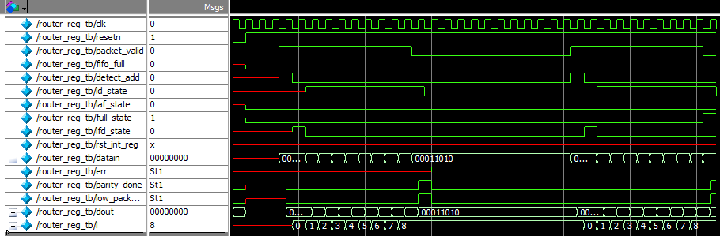

RTL Netlist:

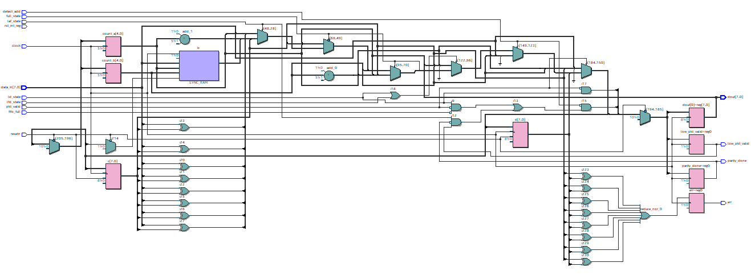

**Router top module:**

RTL:

module router_top(input clock, resetn, read_enb_0, read_enb_1, read_enb_2, pkt_valid,

                  input [7:0] data_in, output [7:0] data_out_0, data_out_1, data_out_2,

                  output valid_out_0, valid_out_1, valid_out_2, error, busy);

wire parity_done,detect_add;

wire ld_state, laf_state, full_state, write_enb_reg, rst_int_reg, lfd_state;

wire [2:0] fifo_empty, full,w_enb, write_enb, soft_reset_temp;

wire fifo_full,low_pkt_valid,soft_reset_0,soft_reset_1,soft_reset_2;

wire [7:0] dout;

wire read_enb_temp[2:0];

wire [7:0] data_out_temp[2:0];

assign soft_reset_temp[0] = soft_reset_0;

assign soft_reset_temp[1] = soft_reset_2;

assign soft_reset_temp[2] = soft_reset_1;

assign read_enb_temp[0] = read_enb_0;

assign read_enb_temp[1] = read_enb_1;

assign read_enb_temp[2] = read_enb_2;

assign data_out_0 = data_out_temp[0];

assign data_out_1 = data_out_temp[1];

assign data_out_2 = data_out_temp[2];

router_fsm dut1(.clock(clock),

                .resetn(resetn),

                .pkt_valid(pkt_valid),

                .parity_done(parity_done),

                .soft_reset_0(soft_reset_0),

                .soft_reset_1(soft_reset_1),

                .soft_reset_2(soft_reset_2),

                .fifo_full(fifo_full),

                .low_pkt_valid(low_pkt_valid),

                .fifo_empty_0(fifo_empty[0]),

                .fifo_empty_1(fifo_empty[1]),

                .fifo_empty_2(fifo_empty[2]),

                .data_in(data_in[1:0]),

                .busy(busy),

                .detect_add(detect_add),

                .ld_state(ld_state),

                .laf_state(laf_state),

                .full_state(full_state),

                .write_enb_reg(write_enb_reg),

                .rst_int_reg(rst_int_reg),

                .lfd_state(lfd_state));

router_reg dut2(.clock(clock),

                .resetn(resetn),

                .pkt_valid(pkt_valid),

                .fifo_full(fifo_full),

                .detect_add(detect_add),

                .ld_state(ld_state),

                .laf_state(laf_state),

                .full_state(full_state),

                .rst_int_reg(rst_int_reg),

                .lfd_state(lfd_state),

                .parity_done(parity_done),

                .low_pkt_valid(low_pkt_valid),

                .err(error),

                .data_in(data_in),

                .dout(dout));

router_sync dut3(.clock(clock),

                .resetn(resetn),

                .detect_add(detect_add),

                .read_enb_0(read_enb_0),

                .read_enb_1(read_enb_1),

                .read_enb_2(read_enb_2),

                .write_enb_reg(write_enb_reg),

                .empty_0(fifo_empty[0]),

                .empty_1(fifo_empty[1]),

                .empty_2(fifo_empty[2]),

                .full_0(full[0]),

                .full_1(full[1]),

                .full_2(full[2]),

                .data_in(data_in[1:0]),

                .vld_out_0(valid_out_0),

                .vld_out_1(valid_out_1),

                .vld_out_2(valid_out_2),

                .soft_reset_0(soft_reset_0),

                .soft_reset_1(soft_reset_1),

                .soft_reset_2(soft_reset_2),

                .fifo_full(fifo_full),

                .write_enb(w_enb));

genvar x;

generate for (x= 0 ; x<3 ; x = x+1)

begin:fifo

    router_fifo f(.clock(clock),

                  .resetn(resetn),

                  .soft_reset(soft_reset_temp[x]),

                  .lfd_state(lfd_state),

                  .write_enb(w_enb[x]),

                  .data_in(dout),

                  .read_enb(read_enb_temp[x]),

                  .full(full[x]),

                  .empty(fifo_empty[x]),

                  .data_out(data_out_temp[x]));

end

endgenerate

endmodule

Test bench:

module router_top_tb();

reg clock, resetn, read_enb_0, read_enb_1, read_enb_2, pkt_valid;

reg [7:0] data_in;

wire [7:0] data_out_0, data_out_1, data_out_2;

wire valid_out_0, valid_out_1, valid_out_2, error, busy;

integer i;

router_top dut(clock, resetn, read_enb_0, read_enb_1, read_enb_2, pkt_valid,data_in,

               data_out_0, data_out_1, data_out_2, valid_out_0, valid_out_1, valid_out_2, error, busy);

initial begin

    clock = 1;

    forever #5 clock = !clock;

end

task reset();

begin

    @(negedge clock);

    resetn =1'b0;

    #10;

    resetn = 1'b1;

end

endtask

task pkt16();

reg [7:0] parity;

reg [5:0] payload_len;

begin

    wait(!busy);

    begin

        @(negedge clock);

        payload_len = 6'b001110;

        pkt_valid = 1'b1;

        data_in = {payload_len,2'b10};

        parity = data_in;

    end

    for(i=0 ; i < payload_len; i=i+1 )

    begin

        wait(!busy)

        @(negedge clock)

        data_in = i*2;

        parity = parity^data_in;

    end

    wait(!busy);

    @(negedge clock)

    pkt_valid = 1'b0;

    data_in = parity;

    repeat(30)

    @(negedge clock);

    data_in = 8'bx;

    read_enb_2 = 1'b1;

end

endtask

initial begin

    reset;

    pkt16;

    #1000;

    $finish;

end

endmodule

WAVE (packet 14):

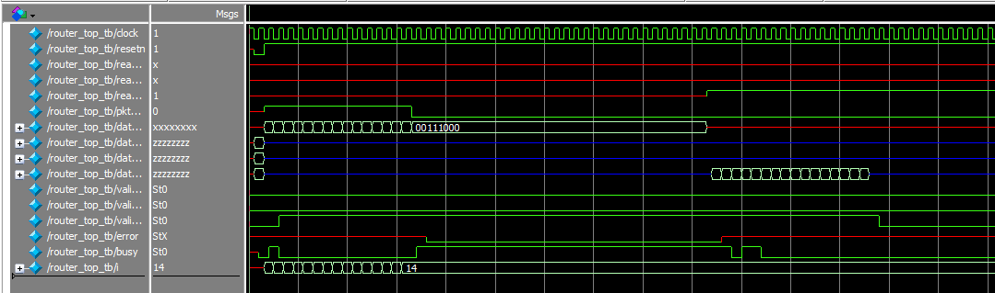 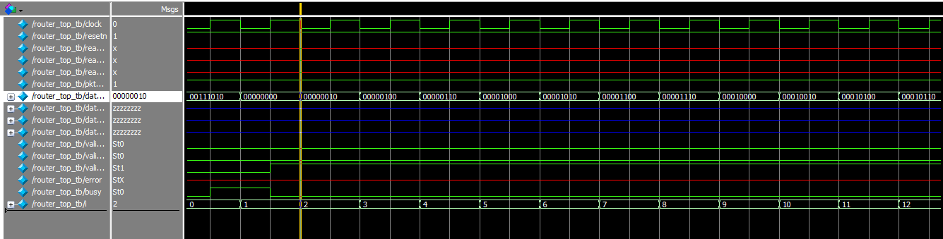 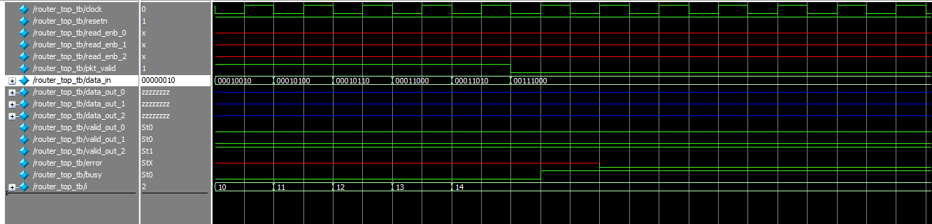 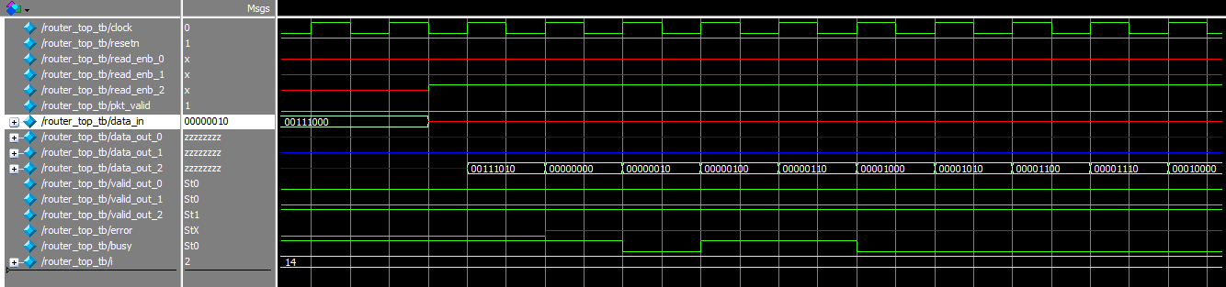 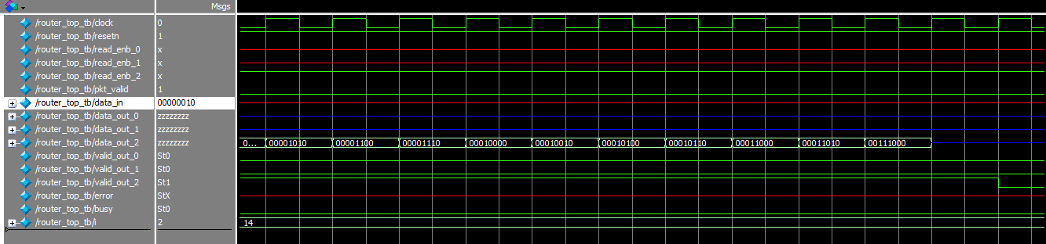

WAVE (packet 16):

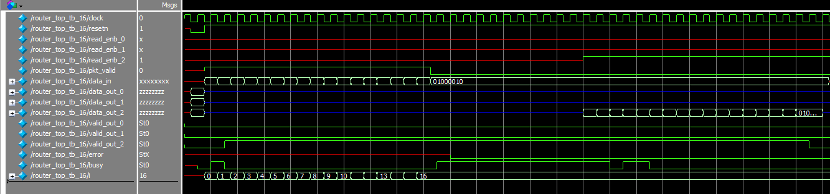

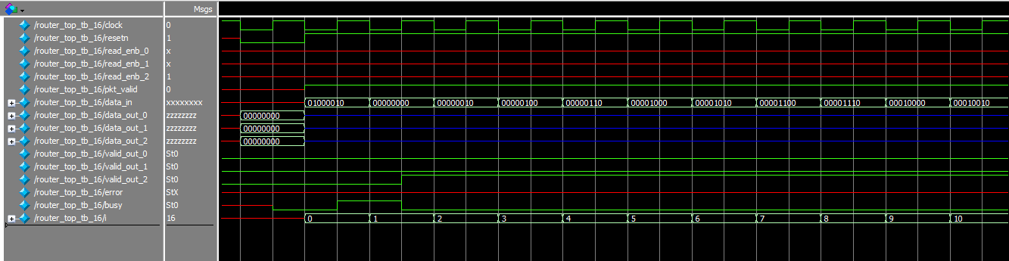

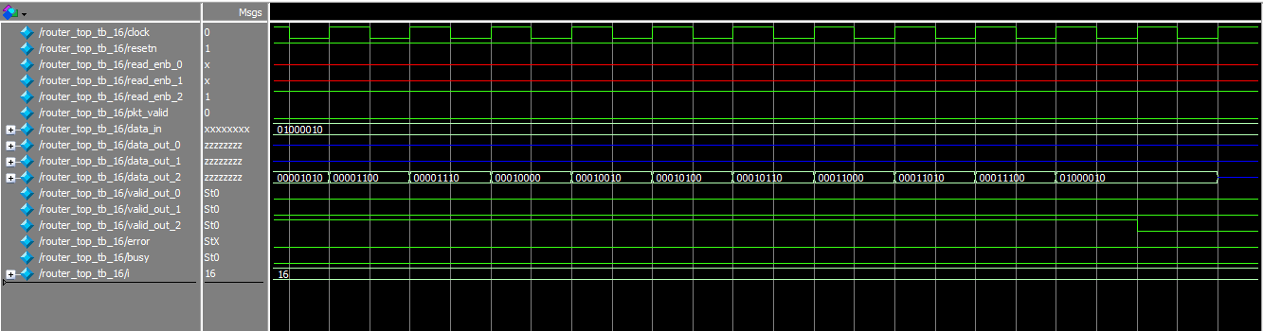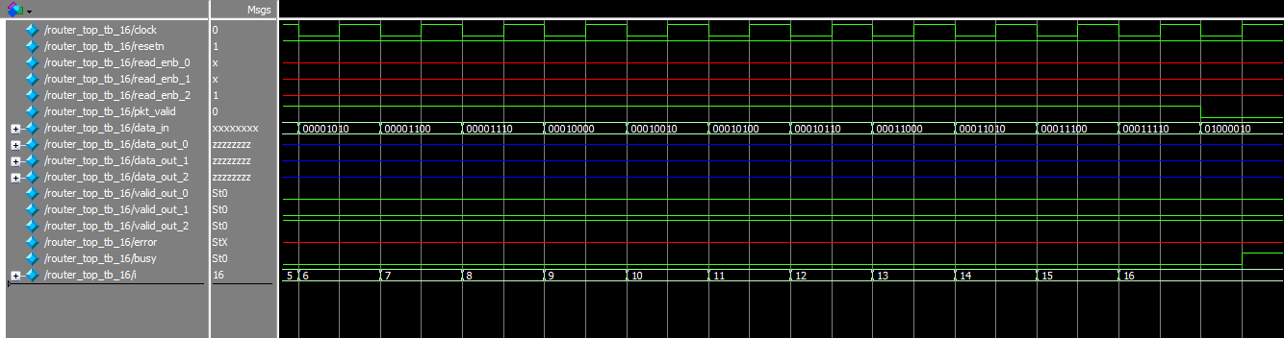

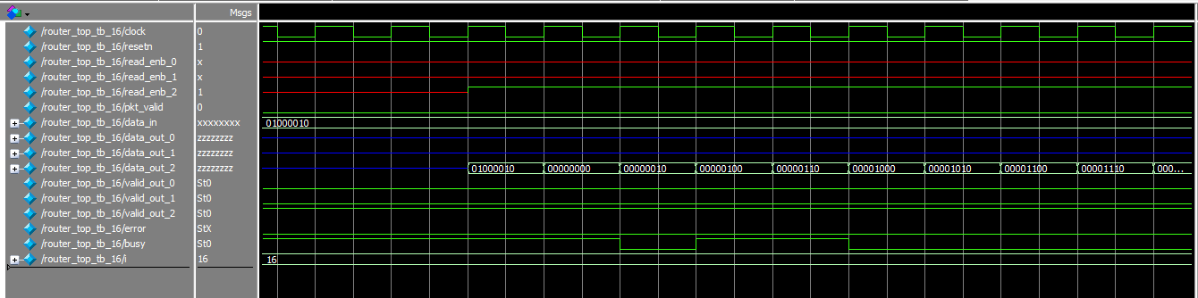

RTL Netlist:

